ASSIGNMENT :
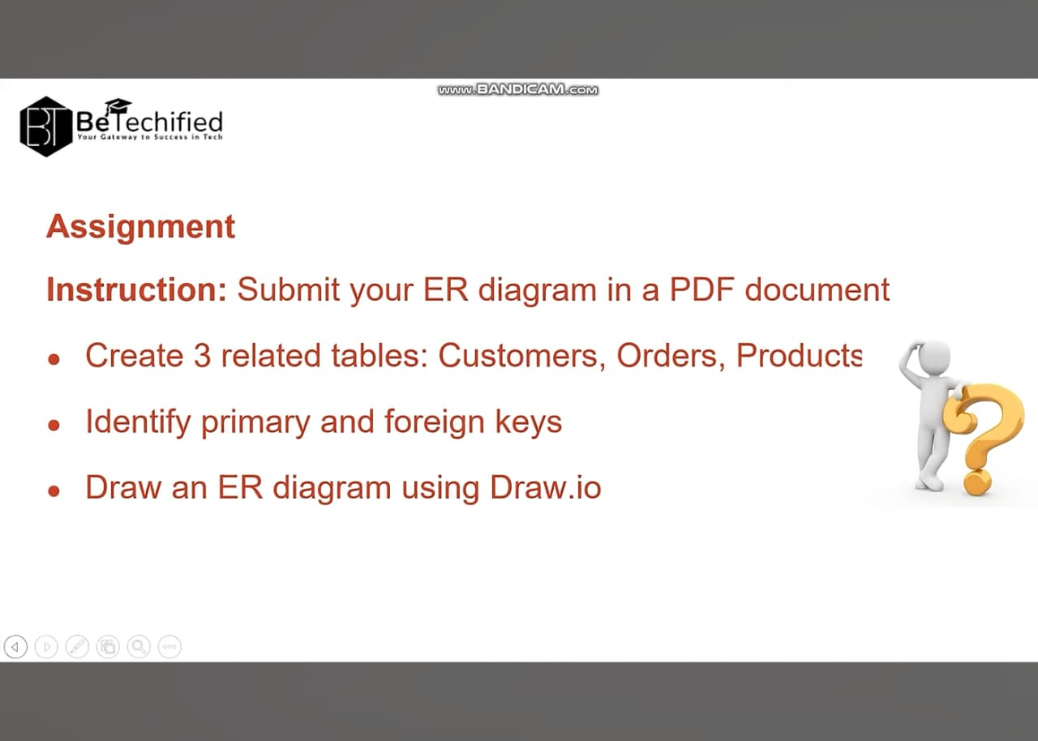

ANSWER: ERD DIAGRAM:
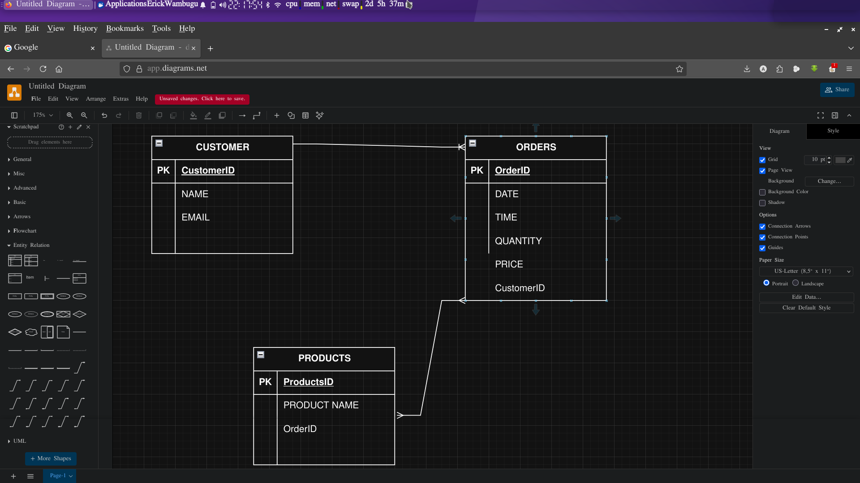

ENTITIES = CUSTOMER , ORDERS, PRODUCTS

CUSTOMER ORDERS PRODUCTS
- Primary Key CustomerID OrderID ProductID
- Foreign Key - CustomerID OrderID

Relationships .
Customer >>>> Orders 1 to Many
Orders >>>> Products Many to Many

